Vighnaharta Ganesh, the use of new technology

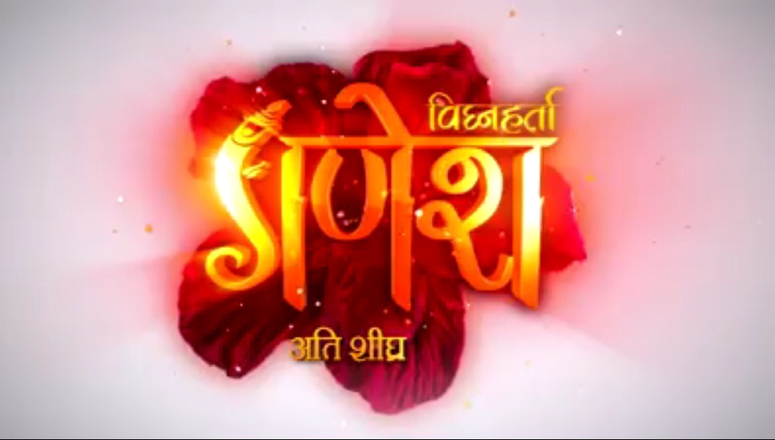The upcoming show of Sony TV "Vighnaharta Ganesh" is going to redefine the mythological trend of the small screen. The show is set to premiere on August 22, 2017, Monday to Friday at 8 pm on Sony.  
Sony Entertainment Television, along with Contiloe Pictures, have come together to show the journey experience of deity Lord Ganesha. The makers of "Vighnaharta Ganesh" have used Motion Capture technology and animatronics and this is happening for the first time in Indian Television. This technology has been used extensively in Hollywood. It will replace the older trend and depictions of Lord Ganesha and will focus on the real moments and facial expressions to give the audience a completely new and delightful view. Basically, "Vighnaharta Ganesh" will be a never seen avtar.   
Abhimanyu Singh, CEO, Contiloe Pictures told exchange4media, "The technology that we have used will accomplish the illusionary. You can understand from the budget of the movie Avatar that has used this technology and you’ll be able to estimate." He further added talking about this new technology, "This is the first time that Motion Capture technology has been used on Indian television. Vighnaharta Ganesh promises to be a milestone in the use of visual effects in the Indian television industry."  
Danish Khan, EVP and Business Head Sony Entertainment Television said, "Story of Lord Ganesh was, is and will always be relevant to our viewers across the globe. The only challenge was to present it in a never-seen-before avatar. We are delighted with the way our creative partner Contiloe has imagined this show visually. We are sure our viewers will enjoy both the editorial authenticity as well as visual delight."  
The show cast includes Uzair Basar playing Ganesha, Akanksha Puri as Parvati, Malkhan Singh as Lord Shiv, Basant Bhatt as Kartikeya and Anand Garodia as Narada Muni.